Supplemental Table 2. Acyl Carnitines
Common Name | Clinical Shorthand | Structure
Acetyl carnitine | C2 | 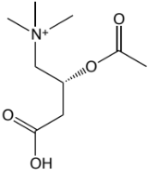
Propionyl carnitine | C3 | 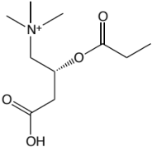
Butyryl carnitine or Isobutyryl carnitine | C4/Ci4 | 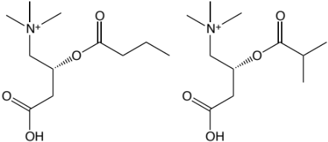
Tiglyl carnitine | C5:1 | 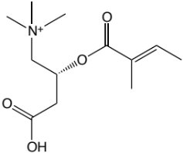
Isovaleryl carnitine, 3-methylbutyryl carnitine or 2-methylbutyryl carntine | C5’s | 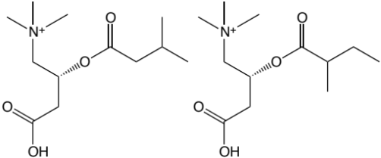
2-Hydroxy-butyryl carnitine, -hydroxy butyryl carnitine | C4-OH | 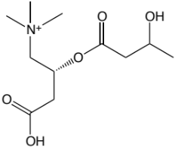
Hexanoyl carnitine | C6 | 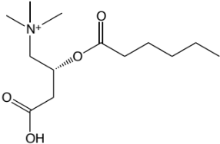
3-Hydroxy-isovaleryl carnitine or Malonyl carnitine | C5-OH/C3-DC | 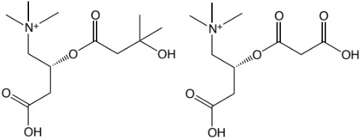
Methylmalonyl carnitine or Succinyl carnitine | Ci4-DC/C4-DC | 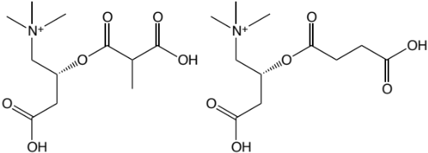

Common Name | Clinical Shorthand | Structure
Octenoyl carnitine | C8:1 | 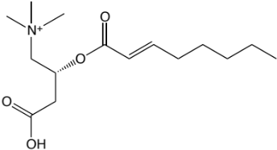
Octanoyl carnitine | C8 | 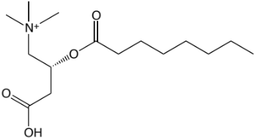
Glutaryl carnitine | C5-DC | 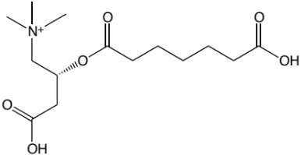
Adipoyl carnitine | C6-DC | 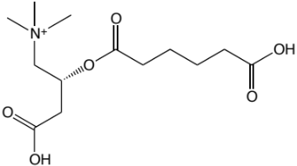
Decatrienoyl carnitine | C10:3 | 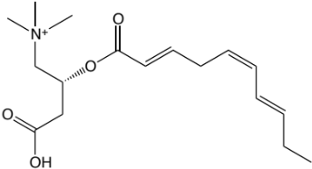
Decadienoyl carnitine | C10:2 | 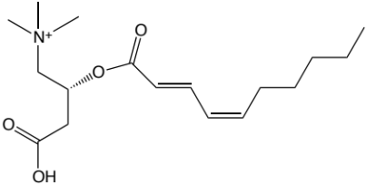
Decenoyl carnitine | C10:1 | 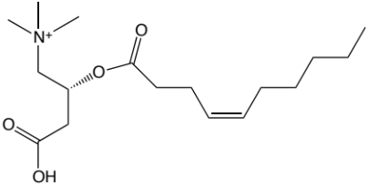
Decanoyl carnitine | C10 | 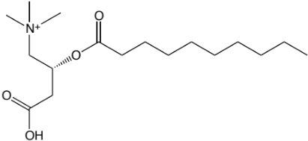
3-Hydroxy-decanoyl carnitine or Suberoyl carnitine | C10-OH/C8-DC | 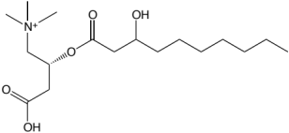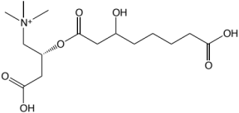

Common Name | Clinical Shorthand | Structure
Dodecenoyl carnitine | C12:1 | 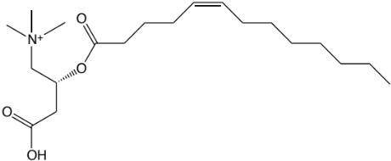
Lauroyl carnitine | C12 | 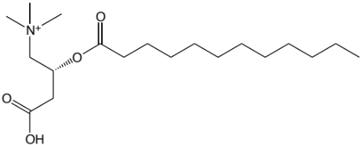
3-Hydroxy-dodecanoyl carnitine or Sebacoyl carnitine | C12-OH/C10-DC | 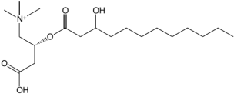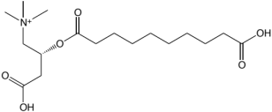
Tetradecadienoyl carnitine | C14:2 | 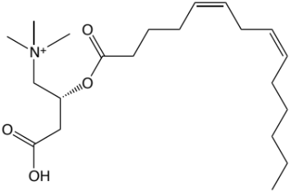
Tetradecadienoyl carnitine | C14:1 | 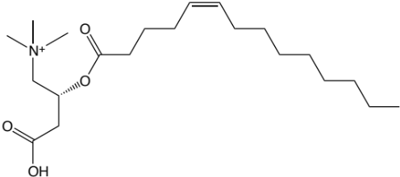
Myristoyl carnitine | C14 | 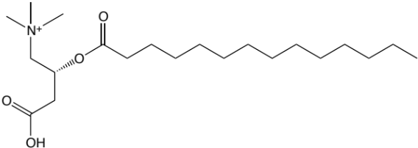
3-Hydroxy-tetradeceonyl carnitine | C14:1-OH | 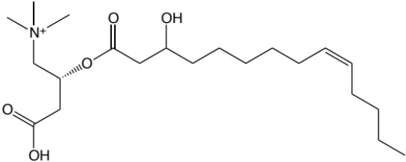
3-Hydroxy-tetradecanoyl carnitine or Dodecanedioyl carnitine | C14-OH/C12-DC | 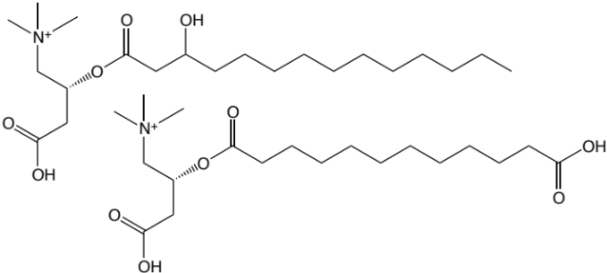

Common Name | Clinical Shorthand | Structure
Palmitoyl carnitine | C16 | 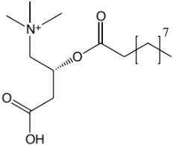
3-Hydroxy-hexadecanoyl carnitine or Tetradecanedioyl carnitine | C16-OH/C14-DC | 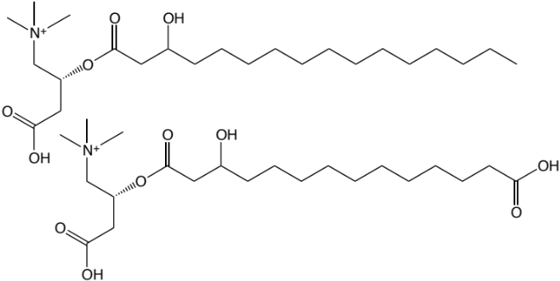
Linoleoyl carnitine | C18:2 | 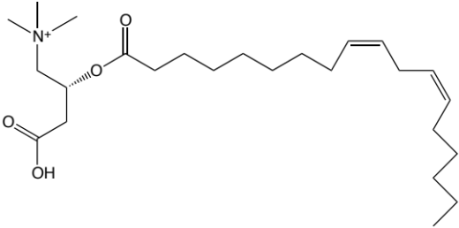
Oleyl carnitine | C18:1 | 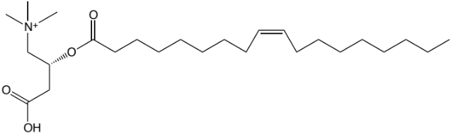
Stearoyl carnitine | C18 | 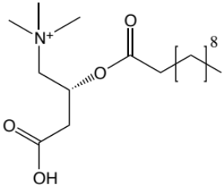
3-Hydroxy-octadecenoyl carnitine | C18:1-OH | 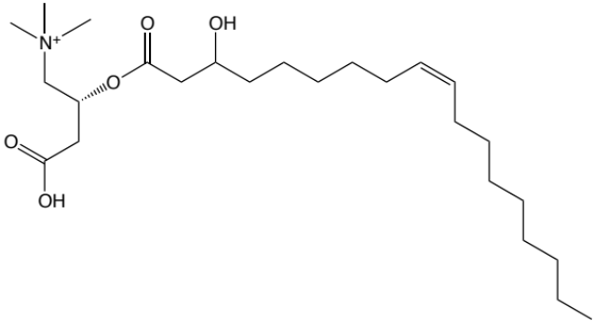
3-Hydroxy-octadecanoyl carnitine or Hexadecanedioyl carnitine, Thapsoyl carnitine | C18-OH/C16-DC | 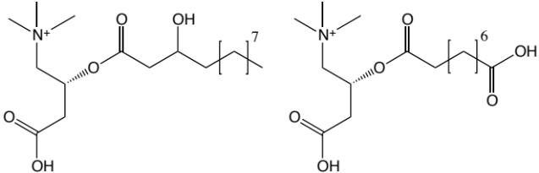

Common Name | Clinical Shorthand | Structure
Arachidoyl carnitine, Eicosanoyl carnitine | C20 | 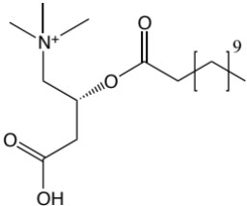
Octadecenedioyl carnitine | C18:1-DC | 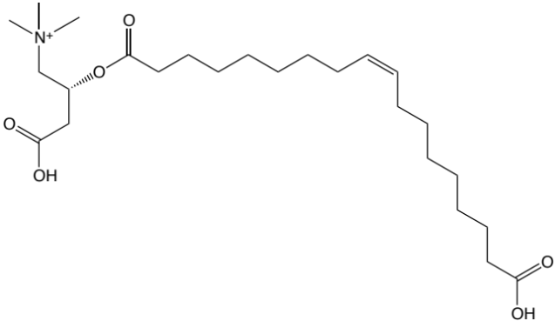
3-Hydroxy-eicosanoyl carnitine or Octadecanedioyl carnitine | C20-OH/C18-DC | 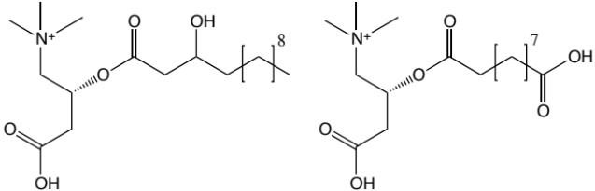
Behenoyl carnitine, Docosanoyl carnitine | C22 | 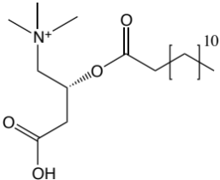
3-Hydroxy-cis-5-octenoyl carnitine or Hexenedioyl carnitine | C8:1-OH/C6:1-DC | 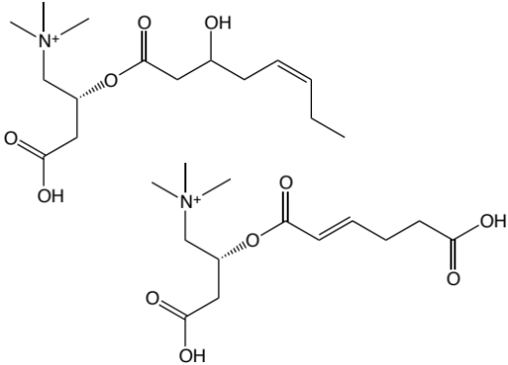
Pimeloyl carnitine, Hepatanedioyl carnitine | C7-DC | 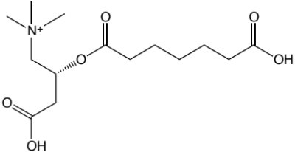
Octenedioyl carnitine | C8:1-DC | 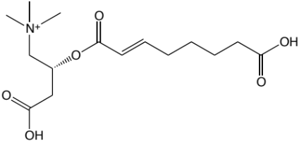

Common Name | Clinical Shorthand | Structure
Hexadecadienoyl carnitine | C16:2 | 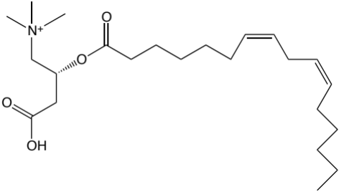
Palmitoleoyl carnitine | C16:1 | 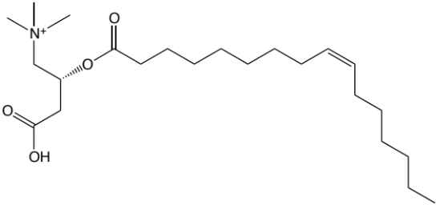
3-Hydroxy-palmitoleoyl carnitine or cis-5-Tetradecenedioyl carnitine | C16:1-OH/C14:1-DC | 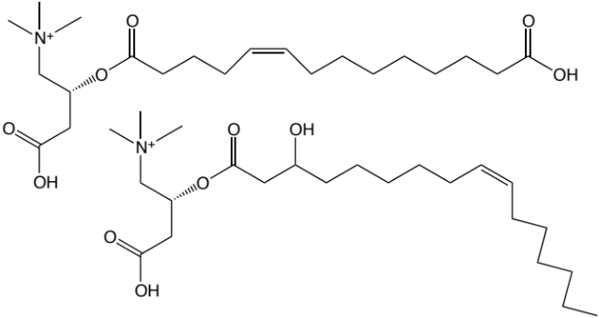
3-Hydroxy-linoleyl carnitine | C18:2-OH | 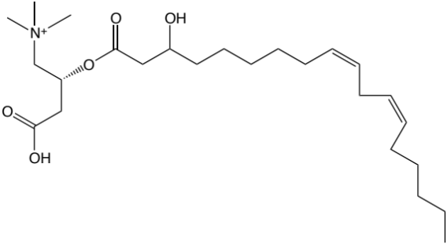
Arachidonoyl carnitine | C20:4 | 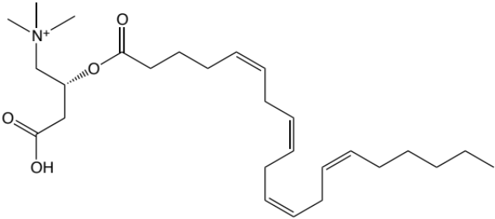

Skeletal Muscle-specific acyl-carnitines:
Common Name | Clinical Shorthand | Structure
3-Hydroxy-dodecenoyl carnitine | C12:1-OH | 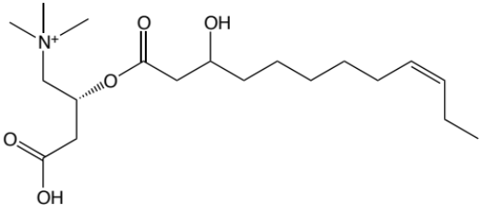
3-Hydroxy-tetradecadienoyl carnitine | C14:2-OH
3-Hydroxy-hexadecadienyl carnitine | C16:2-OH | 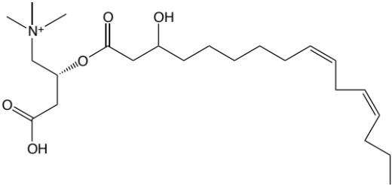
N/A | C18:2-DC/C20:2-OH | N/A
3-Hyrdoxy-octadecanoyl carnitine | C18:3-OH | 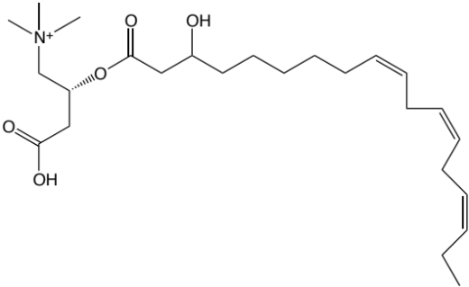

Common Name | Clinical Shorthand | Structure
cis-11-eicoseneoyl carnitine | C20:1 | 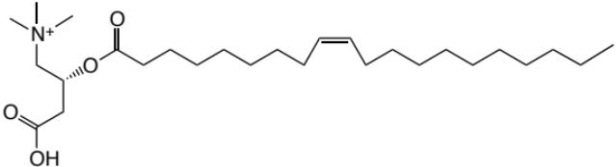
cis-11,14-eicosadieneneoyl carnitine | C20:2 | 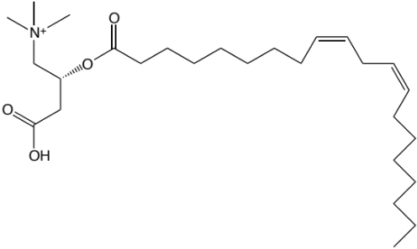
cis-13,16-docosadienoyl carnitine | C22:2 | 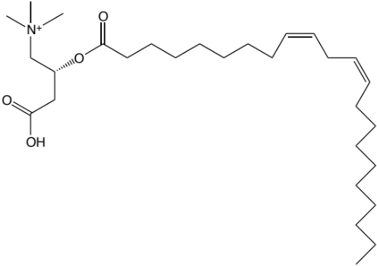
cis-7,10,13,16-docosatetraenoyl carnitine | C22:4 | 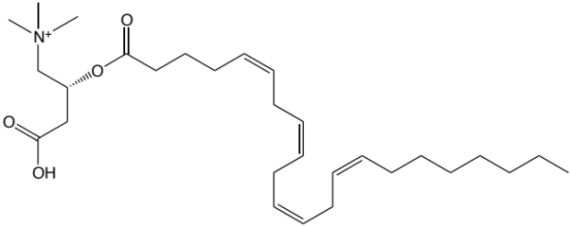
Docosapentaenoyl carnitine | C22:5 | 